**SOUTHERN RIVER COLLEGE**

**Human Biology**

**Unit 4**

**TASK 7**

**Mutations & Gene Pools (5%)**

**TYPE:** Extended Response

**CONTENT:** Mutations & Gene Pools

**TASK 7:** Extended Response **– Mutations & Gene Pools (5%)**

You will have one week to complete your booklet, before completing an in class validation response to unseen questions. You are allowed to have **Part A** with you during the validation.

**Part B and your references** are required to be **submitted prior to sitting the validation**.

**Due Date:**

You must include your references in APA referencing format. Hand this in as a separate sheet attached to your note-taking sheet.

**To be completed:**

* Booklet (to be submitted) 3 marks
* References (APA style) 2 marks
* In Class Validation (Part A as notes ONLY) 25 marks

__________________________________________________

**Total:** 30 Marks

**SOUTHERN RIVER COLLEGE**

**Human Biology**

**Unit 4**

**TASK 7**

**Mutations & Gene Pools (5%)**

**TYPE:** Extended Response

**CONTENT:** Mutations & Gene Pools

This task is in two parts.

Part A requires you to consider gene frequencies in two populations and answering questions relating to it.

Part B involves researching genetic conditions

### Part A: Gene frequencies

The ABO blood typing system is governed by genes IA and IB, which are codominant to the (i) gene. The genotypes and phenotypes that exist are:

IA IA or IA i – type A

IB IB or IBi – type B

IA IB – type AB

ii – type O

The diagram below shows an original population – a hypothetical population of Aboriginals and their blood group genotypes as they may have existed before they migrated to the Australian continent. A number of individuals from this original group migrate to Australia, resulting in the island population as represented in diagram 2.

***Diagram 1 - hypothetical population of Aboriginals and their blood group genotypes***

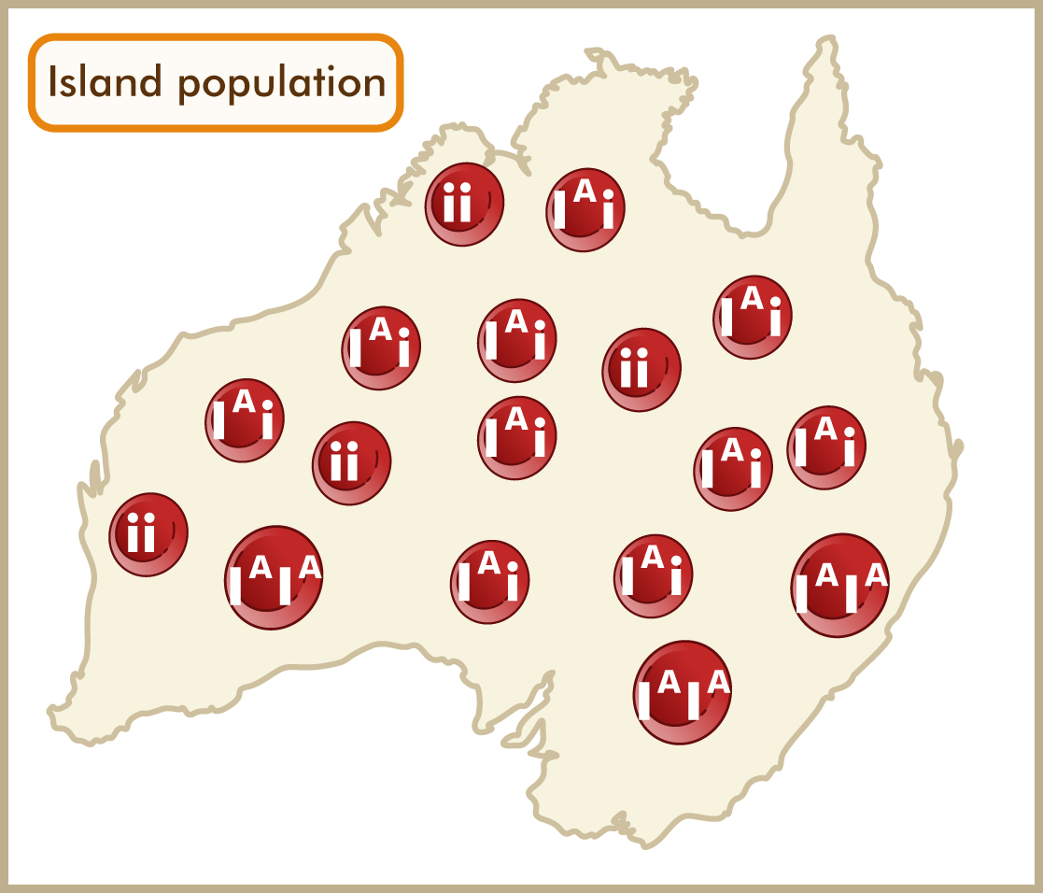***Diagram 2 - hypothetical population of Aboriginals who have migrated to Australia and their blood group genotypes***

1. Record the following in the tables provided:

a) Count the allele frequencies in both populations.

b) Count the number of allele combinations in both populations.

c) Calculate the allele frequencies as percentages for both, *round to 1 decimal place*.

**number of specific alleles  
------------------------------------- x 100  
total number of alleles**

**Gene (allele) frequency (%) =**

|  |  |  |  |  |  |  |  |  |
| --- | --- | --- | --- | --- | --- | --- | --- | --- |
| **Original population** | | **Number counted** | **%** |  | **Island population** | | **Number counted** | **%** |
| **Allele types** Total = _____ | IA |  |  |  | **Allele types**  Total = _____ | IA |  |  |
| IB |  |  |  | IB |  |  |
| i |  |  |  | i |  |  |
| **Allele combinations**  Total = _____ | IAIA |  |  |  | **Allele combinations**  Total = _____ | IAIA |  |  |
| IAi |  |  |  | IAi |  |  |
| IBIB |  |  |  | IBIB |  |  |
| IBi |  |  |  | IBi |  |  |
| IAIB |  |  |  | IAIB |  |  |
| ii |  |  |  | ii |  |  |

2. Calculate the percentage of phenotype frequencies for each of the following:

*Round to 1 decimal place*

|  |  |  |  |  |  |  |  |  |
| --- | --- | --- | --- | --- | --- | --- | --- | --- |
| **Original phenotype frequencies (%)** | | | |  | **Island phenotype frequencies (%)** | | | |
| **Type A** | **Type B** | **Type AB** | **Type O** |  | **Type A** | **Type B** | **Type AB** | **Type O** |
|  |  |  |  |  |  |  |  |  |

**Answer the following questions, as they relate to the given information on the populations.**

3. Describe how the allele frequencies of the two populations differ, explain how this difference occurred.

__________________________________________________________________________________________________________________________________________________

_________________________________________________________________________

_________________________________________________________________________

_________________________________________________________________________

_________________________________________________________________________

___________________________________________________________________________________________________________________________________________________________________________________________________________________________

_________________________________________________________________________

4. Predict what will happen to the allele frequencies for both populations after many generations.

**Use data from the table to support your response.**

_________________________________________________________________________

_________________________________________________________________________

_________________________________________________________________________

_________________________________________________________________________

_________________________________________________________________________

_________________________________________________________________________

_________________________________________________________________________

_________________________________________________________________________

_________________________________________________________________________

5. This type of colonisation of the island can be identified by which term?

_________________________________________________________________________

6. Name ALL other processes which could further alter the allele frequencies of the island population? **Describe** these processes with **specific reference to the island population.**

i. _________________________

_________________________________________________________________________

_________________________________________________________________________

_________________________________________________________________________  
ii._________________________

_________________________________________________________________________

__________________________________________________________________________________________________________________________________________________  
iii. _________________________

_________________________________________________________________________

_________________________________________________________________________

_________________________________________________________________________  
iv.__________________________

_________________________________________________________________________

__________________________________________________________________________________________________________________________________________________  
v. _________________________

_________________________________________________________________________

_________________________________________________________________________

_________________________________________________________________________  
vi. _________________________

__________________________________________________________________________________________________________________________________________________

_________________________________________________________________________

vii. _________________________

__________________________________________________________________________________________________________________________________________________

_________________________________________________________________________

### Part B: Incidence of specific genetic diseases in populations:

|  |  |  |  |  |  |  |
| --- | --- | --- | --- | --- | --- | --- |
| **Genetic disease** | **Cause** | **Genotype**  **(Using**  **T & t)** | **Specific population affected** | **Symptoms  (max 3)** | **Treatment** | **Why is this disease still present in populations?** |
| **Tay Sach’s** (chronic form) |  |  |  |  |  |  |
| **Thalassemia** |  |  |  |  |  |  |
| **Sickle cell anaemia** |  |  |  |  |  |  |